<Project Title>
Major Business Case
v1.0

This template is provided free of charge by the Institute of Project Management under a GNU General Public License.
By downloading and using this resource, you accept its terms and conditions of use.
In short, you can redistribute and/or modify this template to your heart’s content, but without any warranty (real or implied) about its merchantability or fitness for a particular purpose.
This template is offered ‘as is’, and is not supported by a help desk. Please visit http://microsoft.com for editing tips and tricks.
Make sure you remember to delete the <blue guidance text> before submitting it for approval!
You can contact us to learn how this or other project management assets might be customised for your project or organisation.

Project Name:
Location:
Author: | <Name>
 | <Contact details>

1 OPPORTUNITY DEFINITION
<What is the problem we are tring to solve / opportunity we are trying to realise?>

1.1 STRATEGIC ALIGNMENT
<What are the strategic goals of our organisation that these outcomes align to?>

2 METHODOLOGY
<What/who were the key sources consulted in the prepartion of this business case?>

3 ALTERNATIVES ANALYSIS

3.0 Option Zero – Do nothing

<What is the current situation?> | Net financial impact | $ | Useful life
 | Other impacts | <These may include non-financial impacts on the organisation, our client, the community and environment>
 | Measures | <How do we measure these impacts?>
 | Known risks | <These are risks to our organisation of doing nothing>
3.1 Option 1 – <Title>

<Scope> | Project costs | $ | Net financial impact | $
 | Time to deliver |  | Useful life
 | Other impacts | <These may include non-financial impacts on the organisation, our client, the community and environment>
 | Measures | <How will we measure these impacts?>
 | Known risks | <What are risks to our organisation of adopting this option?>

3.2 Option 2 – <Title>

<Scope> | Project costs | $ | Net financial impact | $
 | Time to deliver |  | Useful life
 | Other impacts | <These may include non-financial impacts on the organisation, our client, the community and environment>
 | Measures | <How will we measure these impacts?>
 | Known risks | <What are risks to our organisation of adopting this option?>

3.3 Option 3 – <Title>

<Scope> | Project costs | $ | Net financial impact | $
 | Time to deliver |  | Useful life
 | Other impacts | <These may include non-financial impacts on the organisation, our client, the community and environment>
 | Measures | <How will we measure these impacts?>
 | Known risks | <What are risks to our organisation of adopting this option?>

4 CONCLUSION

 | DO NOTHING | OPTION 1 | OPTION 2 | OPTION 3
Project costs | <MAX>
Net financial impacts
Other impacts
Organisational risk
TOTAL

5 RECOMMENDATION

It is recommended that detailed project planning commence for Option <#>.

5.1 Acceptance criteria / critical success factors
<What is required to successfully manage and deliver the project?>

5.2 Key milestones

Planning commence: |  | Planning complete:
Delivery commence: |  | Delivery complete:

5.3 Proposed budget

Planning | $
Capital expenditure (delivery) | $
Operational expenditure (delivery) | $
Contingency (20%) | $
Total | $

 | In plan* | $ |  | Out of plan | $
*funds already allocated in current budget

6 ACCEPTANCE AND AUTHORISATION TO PROCEED TO DETAILED PLANNING

SIGNATURE Name & Title

TABLE of CONTENTS

1 OPPORTUNITY DEFINITION 6
1.1 STRATEGIC ALIGNMENT 6
2 METHODOLOGY 7
2.1 PRIMARY SOURCES 7
2.2 SECONDARY SOURCES 7
2.3 ASSUMPTIONS AND CONSTRAINTS 7
3 ALTERNATIVES ANALYSIS 8
3.0 OPTION ZERO – DO NOTHING 9
3.1 OPTION ONE – <TITLE> 17
3.2 OPTION TWO – <TITLE> 26
3.3 OPTION THREE – <TITLE> 35
4 CONCLUSION 44
5 RECOMMENDATION 45
5.1 ACCEPTANCE CRITERIA / CRITICAL SUCCESS FACTORS 45
5.2 KEY MILESTONES 46
5.3 PROJECT BUDGET 46
APPENDICES 47
A GLOSSARY 47
B FEASIBILITY STUDIES 49
C DETAILED COST BREAKDOWNS 49
D FINANCIAL ANALYSES 49
E TECHNICAL SPECIFICATIONS 50
F LEGAL / REGULATORY REQUIREMENTS 50
G SUPPLIER QUOTES, TENDERS AND CONTRACTS 50
H OTHER RELEVANT CORRESPONDENCE 50
I USEFUL CONTACTS 50
J CONFIGURATION HISTORY 50

1 OPPORTUNITY DEFINITION
What is the problem we are trying to solve, or the opportunity we are trying to realise?

Give a little background and describe the context of the work unit or organisation that you represent. Include the relevant history of the system, process or item of plant or equipment that you are proposing to change. This would include matters such as performance, reliability, equipment life cycle, deviations from the norm, risks et cetera.

This section is also intended to change the way the business thinks about the situation. Instead of a reporting on a problem (for example, slow computer networks are constraining productivity by 20 per cent), a business case is meant to highlight an opportunity (by upgrading our computer networks we can be 20 per cent more productive!).

You should focus here on root causes of the problem, and not symptoms. For example, the root cause of a machine failure may not actually be that the motor keeps blowing up – it might be that the operators are overloading it. Therefore, our solution should be a one hour group training session, as opposed to purchasing entirely new equipment.

1.1 STRATEGIC ALIGNMENT
You should also explain why the problem matters – link it to the objectives of your organisation.
Where possible, you should directly reference the objectives and strategies of the most recent Strategic / Corporate Plan.
Any relevant divisional or departmental goals should also be cited.

2 METHODOLOGY
Describe how you prepared the business case. To establish the authority for your findings, you should also list here the primary and secondary sources consulted.

2.1 PRIMARY SOURCES
Primary sources are stakeholders you directly spoke to when developing the business case.
These might include internal business resources (such as engineers, finance and HR); external sources (such as contractors, consultants and regulators); and end-users (such as other business units and the community).

2.2 SECONDARY SOURCES
Secondary sources come from your ‘desktop’ research and might include authoritative reports, cases, relevant legislation and reviews of like projects etc.

2.3 ASSUMPTIONS AND CONSTRAINTS
It is also useful to list any assumptions that might be present in your analysis, and the limitations or constraints placed on your study.
Included here might be assumptions about (or constraints relating to) scope, schedule, cost, quality, risk, stakeholders (including stakeholders not consulted) and procurements. This may also include assumptions arising from previous documents, such as a Project Proposal, a Feasibility Study or other existing strategic business documents.
Consider, too, the implications if an assumption is wrong.

3 ALTERNATIVES ANALYSIS
Analysis of alternatives is the whole purpose of the business case. To convince someone to pay for the project, you need to show more than just one solution to the problem – you need to prove the best solution. This involves the analysis of all practical alternatives and most importantly, the degree to which the alternatives satisfy the identified needs.
Option 1 is always the null hypothesis: this is what will happen if we do nothing (the base case).
The next options – and you should really list no more than two to four more alternatives – should be presented in sufficient detail for the decision makers to tell the difference between each option and their outcomes.
In doing so you must describe the costs and impacts of each alternative, assess the risks to the organisation attached to them, and introduce any other criteria relevant to the assessment. A criteria is relevant if it is likely to significantly differ from one alternative to the next.
Some introductory narrative around feasibility may also be appropriate for each alternative, even though this may not be an explicit criteria for final ranking.
NOTE: Financial impacts should be presented in today’s dollars (even if projected out over a number of years).

3.0 OPTION ZERO – DO NOTHING
Quite often, Option Zero will be the problem!
Describe in detail what ‘doing nothing’ might involve (scope).
Any requirements for specialist resources or skills should also be identified here, as well as any dependencies that exist with other projects or initiatives.

3.0.1 Project (output) costs
Option Zero has no project costs, as no project is proposed.

3.0.2 Net financial impact
The net financial impact of the null alternative is the ordinary revenue that would flow from relevant business as usual, less the ownership (operating) costs.
To reflect the uncertainty of estimates at the business case stage, a standard margin of error of 20% is applied. It would be unusual if a larger margin was needed, and this would need to be fully explained.
It is also important that when you compare the financials of different alternatives that you standardise the timeframe. The figures for every Option should therefore be presented here as being over the same total time (eg five years).

Revenue |  | over <x> years
less Ownership costs |  | over <x> years
Net financial impact |  | over <x> years

Best case (+20% revenue / -20% costs)
Worst case (-20% revenue / +20% costs)

On larger projects, you might also like to discount this outcome by its net present value. If NPV < 0, then the Option cannot be justified on financial grounds – there must be other compelling benefits for this Option if we are to pursue it.

3.0.2.1 Revenue
If revenue is returned to the organisation as a result of doing nothing, it should be reported here.
Savings are unlikely to be realised by Option Zero. Note that ‘not having to pay for the other options’ is not a true financial impact. This is because we will factor in the cost of delivering those Options later in this report.
You should also discuss in this Section your basis for estimating these costs, as well as your level of confidence in the estimates (margin of error).

 | Year 1 | Year 2 | Year 3 | Year 4 | Year 5 | Total
Revenue
Savings
Total

3.0.2.2 Ownership costs
If the organisation is to do nothing, then the lifetime cost of ‘doing nothing’ should be factored into our decision.
This enables us to compare solutions with different working lives (for example, five versus ten years), and solutions with different operating costs (for example, two users versus five to do the same task).
You should also discuss in this Section your basis for estimating these costs, as well as your level of confidence in the estimates (margin of error).
If the business sells or otherwise disposes of an asset as part of this Option, then the cost will be recovered and recorded as income in the next Section (see below).

 | Year 1 | Year 2 | Year 3 | Year 4 | Year 5 | Total
Labour
Materials
Compliance
Overheads
Other
Total

Compliance costs might include safety training, quality control and (especially in the case of Option Zero) anticipated fines from regulators.
Overheads are administrative and other charges generally incurred by the organisation (such as rent, electricity, telephone, photocopying, insurance) that should be attributed to the asset, usually on a pro rata or fixed fee for service (eg per day).
Other costs might include ongoing operator training and the forecast costs of necessary upgrades or decommissioning – add as many rows here as you feel necessary.
It is important to note that some of these costs may increase over time as the solution deteriorates. Note that you do not forecast for CPI (cost of living) increases here – only the increase in costs likely to be associated with ordinary wear and tear.
On larger projects, you might also like to consider the oppportunity cost of these investments.

3.0.3 Other impacts
Other impacts are the non-monetary (intangible) outcomes delivered by a project. They are generally classified by the bearers of these impacts.
As it is difficult to apply a single, standard unit of measure to these impacts (such as money), we often rate them with a subjective score. To the extent that it is possible to do so, you should explain and justify your scoring methodology.
Impact scores may also be weighted. For example, if you wish to prioritise impacts to our organisation, the organisation score can be weighted (multiplied) by 4 times to indicate its relative importance. Weightings – and the assumptions that underpin them – must be fully disclosed (usually as an Appendix attachment).

 | WEIGHT | RATING | SCORE
Our organisation
Our clients
The community / environment
Weight x Rating = Score |  | Total

3.0.3.1 Impacts on our organisation
Impacts on our organisation of doing nothing can include changes to our:
- Knowledge and/or skills (which should lead to improvements in productivity)
- Stakeholder networks
- Brand / reputation
- Corporate culture, and
- Competitive advantage
In the narrative that follows, you should link these impacts to the objectives of our organisation’s Strategic Plan. In presenting this information, it is important to develop it as a logical analysis; if any elements are not relevant to the null alternative, they should not be mentioned.
Some impacts may also be harmful, and should be recorded as such.
It is also vitally important to benchmark the impacts of Option Zero so that we can compare them at least indirectly to the other alternatives proposed.
Commonly used effectiveness metrics include:
- Unit throughput (for example, the number of people trained, or the number of patients treated)
- Event tallies (for example, the number of safety incidents, or the number errors in production)
- Customer satisfaction ratings (such as Likert scales, where five is very happy and one is very sad), and
- Qualitative analysis of commentary (for example, the ratio of positive to negative feedback).

3.0.3.2 Impacts on our clients
In this instance, our clients are individuals or organisations who currently directly purchase the goods and services we produce that are relevant this busniess case. Impacts on our organisational clients of doing nothing can also include changes to their:
- Knowledge and/or skills (which should lead to improvements in productivity)
- Stakeholder networks
- Brand / reputation
- Corporate culture, and
- Competitive advantage
If our clients are individual consumers, the their personal well-being may also be impacted by our organisation doing nothing.
In the narrative that follows, you should link these impacts to the objectives of our organisation’s Strategic Plan. In presenting this information, it is important to develop it as a logical analysis; if any elements are not relevant to the null alternative, they should not be mentioned.
Some impacts may also be harmful, and should be recorded as such.
It is also vitally important to benchmark the impacts of Option Zero so that we can compare them at least indirectly to the other alternatives proposed.
Commonly used effectiveness metrics include:
- Unit throughput (for example, the number of people trained, or the number of patients treated)
- Event tallies (for example, the number of safety incidents, or the number errors in production)
- Customer satisfaction ratings (such as Likert scales, where five is very happy and one is very sad), and
- Qualitative analysis of commentary (for example, the ratio of positive to negative feedback).

3.0.3.3 Impacts on the community / environment
The community is defined here as non-purchasers or our relevant goods and/or services. Their personal well-being may also be impacted by our organisation doing nothing.
In the narrative that follows, you should link these impacts to the objectives of our organisation’s Strategic Plan. In presenting this information, it is important to develop it as a logical analysis; if any elements are not relevant to the null alternative, they should not be mentioned.
Some impacts may also be harmful, and should be recorded as such.
It is also vitally important to benchmark the impacts of Option Zero so that we can compare them at least indirectly to the other alternatives proposed.

3.0.4 Risks to our organisation
At the project initiation stage, we are interested in the relative risk to our organisation of proceeding with each Option. It is therefore important that we assess each alternative against the same criteria.
Note that when compared to the risk assessment for the other, project-based options, a number of criteria are not relevant to the Option Zero risk assessment. This is why it is important to convert risk scores to a percentage to facilitate ease of comparison.
These criteria can be updated or added to as required, as long as it is done consistently for each Option and in accordance with organisational policies.

 | LOW (1) | MEDIUM (3) | HIGH (5) | Score
SAFETY | No employee or public health or safety risks | Employees and/or public may be at risk of minor injury or illness | Employees and/or public may be at risk of serious injury, illness or loss of life | / 5
STRATEGIC IMPORTANCE | Outcomes link to only one (1) strategic objective of our organisation | Outcomes link to several strategic objectives of our organisation | Outcomes affect core service delivery and directly impacts key strategic objectives | / 5
OPERATIONAL IMPACT | Impacts only one (1) department in our organisation | Impacts several departments in our organisation | Impacts most or all of our organisation and/or may disrupt continuity of service | / 5
DEPENDENCIES | No major dependencies and/or inter-related projects | Some major dependencies and/or inter-related projects | Major, high-risk dependencies and/or inter-related projects | / 5
BRAND / REPUTATION | Project is only of internal interest to our organisation | There is likely to be some community interest in our project / outcomes | This project and/or its outcomes will be highly visible in the community | / 5
Total |  |  |  | / 25
Percent |  |  |  | %

Project level risks are more appropriately considered in the detail project plan; however, some may be flagged here for future consideration or as justification for the ratings given above.

3.1 OPTION ONE – <TITLE>
Describe in detail what is proposed by the Option (scope), clearly linking it to the opportunity defined in Section 1.
Any requirements for specialist resources or skills should also be identified here, as well as any dependencies that exist with other projects or initiatives.

3.1.1 Project (output) costs
Capital costs include all the resources partially used (depreciated) by the project and returned to the organisation once the project is complete. These might include land, buildings, motor vehicles, computers and the like that, from an accounting point of view, appear on the balance sheet assets.
Materials are goods wholly consumed by the project, such as concrete, timber, hire equipment and the like. These appear in our financial statements as an expense.
You must also allow for the wages, salaries and on-costs (such as holiday and sick leave) of the project team, including contractors and consultants. You should also include any relevant travel and accommodation required by the project in this category.
Transfer costs are incurred in taking the project live; in other words, transferring the output(s) from the project team to the client. These might include things such as user documentation, training manuals and client walk-throughs.
Other indirect (overhead) costs may also be considered here, especially if the indirect costs of one or more alternatives are significantly different.

Capital
Materials
Labour
Contractors / consultants
Transfers
Other
Total

Where appropriate, you should discuss the basis for estimating these costs and your level of confidence in these estimates.
On larger projects, you might also like to consider the oppportunity cost of these investments.
3.1.2 Net financial impact
The net financial impact of a project alternative is the ordinary revenue that would flow from relevant business as usual, less the ownership (operating) costs.
To reflect the uncertainty of estimates at the business case stage, a standard margin of error of 20% is applied. It would be unusual if a larger margin was needed, and this would need to be fully explained.
It is also important that when you compare the financials of different alternatives that you standardise the timeframe. The figures for every Option should therefore be presented here as being over the same total time (eg five years).

Revenue / savings |  | over <x> years
less Ownership costs |  | over <x> years
Net financial impact |  | over <x> years

Best case (+20% revenue / -20% costs)
Worst case (-20% revenue / +20% costs)

On larger projects, you might also like to discount this outcome by its net present value. If NPV < 0, then the Option cannot be justified on financial grounds – there must be other compelling benefits for this Option if we are to pursue it.

3.1.2.1 Revenue
If revenue is anticipated from this Option, it should be reported here. Financial impacts traditionally arrive as sales, but can also come about through savings on internally owned projects (for example, through reduced travel time or operational efficiencies).
However, labour savings (for example) should only be included as a saving when someone is no longer paid. If a project provides more free time, but will not result in a reduction in employee hours then it is not a saving as there will be no change to the amount of money the organisation outlays.
You should also discuss in this Section your basis for estimating these costs, as well as your level of confidence in the estimates (margin of error).

 | Year 1 | Year 2 | Year 3 | Year 4 | Year 5 | Total
Revenue
Savings
Total

3.1.2.2 Ownership costs
If the organisation is to retain (or provide after-sales servcing or warranties to) the deliverable, then its lifetime cost should be factored into our decision.
This enables us to compare solutions with different working lives (for example, five versus ten years), and solutions with different operating costs (for example, two users versus five to do the same task).
You should also discuss in this Section your basis for estimating these costs, as well as your level of confidence in the estimates (margin of error).
If the business sells or otherwise disposes of an asset as part of this Option, then the cost will be recovered and recorded as income in the next Section (see below).

 | Year 1 | Year 2 | Year 3 | Year 4 | Year 5 | Total
Labour
Materials
Compliance
Overheads
Other
Total

Compliance costs might include safety training, quality control and (especially in the case of Option Zero) anticipated fines from regulators.
Overheads are administrative and other charges generally incurred by the organisation (such as rent, electricity, telephone, photocopying, insurance) that should be attributed to the asset, usually on a pro rata or fixed fee for service (eg per day).
Other costs might include ongoing operator training and the forecast costs of necessary upgrades or decommissioning – add as many rows here as you feel necessary.
It is important to note that some of these costs may increase over time as the solution deteriorates. Note that you do not forecast for CPI (cost of living) increases here – only the increase in costs likely to be associated with ordinary wear and tear.
On larger projects, you might also like to consider the oppportunity cost of these investments.

3.1.3 Other impacts
Other impacts are the non-monetary (intangible) outcomes delivered by a project. They are generally classified by the bearers of these impacts.
As it is difficult to apply a single, standard unit of measure to these impacts (such as money), we often rate them with a subjective score. To the extent that it is possible to do so, you should explain and justify your scoring methodology.
Impact scores may also be weighted. For example, if you wish to prioritise impacts to our organisation, the organisation score can be weighted (multiplied) by 4 times to indicate its relative importance. Weightings – and the assumptions that underpin them – must be fully disclosed (usually as an Appendix attachment).

 | WEIGHT | RATING | SCORE
Our organisation
Our clients
The community / environment
Weight x Rating = Score |  | Total

3.1.3.1 Impacts on our organisation
Impacts on our organisation of preferring this Option can include changes to our:
- Knowledge and/or skills (which should lead to improvements in productivity)
- Stakeholder networks
- Brand / reputation
- Corporate culture, and
- Competitive advantage
In the narrative that follows, you should link these impacts to the objectives of our organisation’s Strategic Plan. In presenting this information, it is important to develop it as a logical analysis; if any elements are not relevant to the null alternative, they should not be mentioned.
Some impacts may also be harmful, and should be recorded as such.
Commonly used effectiveness metrics include:
- Unit throughput (for example, the number of people trained, or the number of patients treated)
- Event tallies (for example, the number of safety incidents, or the number errors in production)
- Customer satisfaction ratings (such as Likert scales, where five is very happy and one is very sad), and
- Qualitative analysis of commentary (for example, the ratio of positive to negative feedback).

3.1.3.2 Impacts on our clients
In this instance, our clients are individuals or organisations who currently directly purchase the goods and services we produce that are relevant this busniess case. Impacts on our organisational clients of preferring this Option can also include changes to their:
- Knowledge and/or skills (which should lead to improvements in productivity)
- Stakeholder networks
- Brand / reputation
- Corporate culture, and
- Competitive advantage
If our clients are individual consumers, the their personal well-being may also be impacted by our organisation doing nothing.
In the narrative that follows, you should link these impacts to the objectives of our organisation’s Strategic Plan. In presenting this information, it is important to develop it as a logical analysis; if any elements are not relevant to the null alternative, they should not be mentioned.
Some impacts may also be harmful, and should be recorded as such.
Commonly used effectiveness metrics include:
- Unit throughput (for example, the number of people trained, or the number of patients treated)
- Event tallies (for example, the number of safety incidents, or the number errors in production)
- Customer satisfaction ratings (such as Likert scales, where five is very happy and one is very sad), and
- Qualitative analysis of commentary (for example, the ratio of positive to negative feedback).

3.1.3.3 Impacts on the community / environment
The community is defined here as non-purchasers or our relevant goods and/or services. Their personal well-being may also be impacted by our organisation preferring this Option.
In the narrative that follows, you should link these impacts to the objectives of our organisation’s Strategic Plan. In presenting this information, it is important to develop it as a logical analysis; if any elements are not relevant to the null alternative, they should not be mentioned.
Some impacts may also be harmful, and should be recorded as such.

3.1.4 Risks to our organisation
At the project initiation stage, we are interested in the relative risk to our organisation of proceeding with each Option. It is therefore important that we assess each alternative against the same criteria.
These criteria can be updated or added to as required, as long as it is done consistently for each Option.
 | LOW (1) | MEDIUM (3) | HIGH (5) | Score
COMPLEXITY | Opportunity is clear and project solution is readily achievable | Either opportunity or project is difficult to understand or achieve | Opportunity and project are difficult to understand or achieve | / 5
TIME | <3 months and/or flexible timeframe | <6 months and/or some schedule flexibility | >6 months and/or schedule and delivery date are fixed | / 5
LEARNING CURVE | Successfully completed this type of project five (5) or more times | Successfully completed this type of project at least once | We have not successfully completed this type of project before | / 5
SAFETY | No employee or public health or safety risks | Employees and/or public may be at risk of minor injury or illness | Employees and/or public may be at risk of serious injury, illness or loss of life | / 5
STRATEGIC IMPORTANCE | Outcomes link to only one (1) strategic objective of our organisation | Outcomes link to several strategic objectives of our organisation | Outcomes affect core service delivery and directly impacts key strategic objectives | / 5
OPERATIONAL IMPACT | Impacts only one (1) department in our organisation | Impacts several departments in our organisation | Impacts most or all of our organisation and/or may disrupt continuity of service | / 5
DEPENDENCIES | No major dependencies and/or inter-related projects | Some major dependencies and/or inter-related projects | Major, high-risk dependencies and/or inter-related projects | / 5
BRAND / REPUTATION | Project is only of internal interest to our organisation | There is likely to be some community interest in our project / outcomes | This project and/or its outcomes will be highly visible in the community | / 5
Total |  |  |  | / 40
Percent |  |  |  | %

Project level risks are more appropriately considered in the detail project plan; however, some may be flagged here for future consideration or as justification for the ratings given above.

3.2 OPTION TWO – <TITLE>
Describe in detail what is proposed by the Option (scope), clearly linking it to the opportunity defined in Section 1.
Any requirements for specialist resources or skills should also be identified here, as well as any dependencies that exist with other projects or initiatives.

3.2.1 Project (output) costs
Capital costs include all the resources partially used (depreciated) by the project and returned to the organisation once the project is complete. These might include land, buildings, motor vehicles, computers and the like that, from an accounting point of view, appear on the balance sheet assets.
Materials are goods wholly consumed by the project, such as concrete, timber, hire equipment and the like. These appear in our financial statements as an expense.
You must also allow for the wages, salaries and on-costs (such as holiday and sick leave) of the project team, including contractors and consultants. You should also include any relevant travel and accommodation required by the project in this category.
Transfer costs are incurred in taking the project live; in other words, transferring the output(s) from the project team to the client. These might include things such as user documentation, training manuals and client walk-throughs.
Other indirect (overhead) costs may also be considered here, especially if the indirect costs of one or more alternatives are significantly different.

Capital
Materials
Labour
Contractors / consultants
Transfers
Other
Total

Where appropriate, you should discuss the basis for estimating these costs and your level of confidence in these estimates.
On larger projects, you might also like to consider the oppportunity cost of these investments.
3.2.2 Net financial impact
The net financial impact of a project alternative is the ordinary revenue that would flow from relevant business as usual, less the ownership (operating) costs.
To reflect the uncertainty of estimates at the business case stage, a standard margin of error of 20% is applied. It would be unusual if a larger margin was needed, and this would need to be fully explained.
It is also important that when you compare the financials of different alternatives that you standardise the timeframe. The figures for every Option should therefore be presented here as being over the same total time (eg five years).

Revenue / savings |  | over <x> years
less Ownership costs |  | over <x> years
Net financial impact |  | over <x> years

Best case (+20% revenue / -20% costs)
Worst case (-20% revenue / +20% costs)

On larger projects, you might also like to discount this outcome by its net present value. If NPV < 0, then the Option cannot be justified on financial grounds – there must be other compelling benefits for this Option if we are to pursue it.

3.2.2.1 Revenue
If revenue is anticipated from this Option, it should be reported here. Financial impacts traditionally arrive as sales, but can also come about through savings on internally owned projects (for example, through reduced travel time or operational efficiencies).
However, labour savings (for example) should only be included as a saving when someone is no longer paid. If a project provides more free time, but will not result in a reduction in employee hours then it is not a saving as there will be no change to the amount of money the organisation outlays.
You should also discuss in this Section your basis for estimating these costs, as well as your level of confidence in the estimates (margin of error).

 | Year 1 | Year 2 | Year 3 | Year 4 | Year 5 | Total
Revenue
Savings
Total

3.2.2.2 Ownership costs
If the organisation is to retain (or provide after-sales servcing or warranties to) the deliverable, then its lifetime cost should be factored into our decision.
This enables us to compare solutions with different working lives (for example, five versus ten years), and solutions with different operating costs (for example, two users versus five to do the same task).
You should also discuss in this Section your basis for estimating these costs, as well as your level of confidence in the estimates (margin of error).
If the business sells or otherwise disposes of an asset as part of this Option, then the cost will be recovered and recorded as income in the next Section (see below).

 | Year 1 | Year 2 | Year 3 | Year 4 | Year 5 | Total
Labour
Materials
Compliance
Overheads
Other
Total

Compliance costs might include safety training, quality control and (especially in the case of Option Zero) anticipated fines from regulators.
Overheads are administrative and other charges generally incurred by the organisation (such as rent, electricity, telephone, photocopying, insurance) that should be attributed to the asset, usually on a pro rata or fixed fee for service (eg per day).
Other costs might include ongoing operator training and the forecast costs of necessary upgrades or decommissioning – add as many rows here as you feel necessary.
It is important to note that some of these costs may increase over time as the solution deteriorates. Note that you do not forecast for CPI (cost of living) increases here – only the increase in costs likely to be associated with ordinary wear and tear.
On larger projects, you might also like to consider the oppportunity cost of these investments.

3.2.3 Other impacts
Other impacts are the non-monetary (intangible) outcomes delivered by a project. They are generally classified by the bearers of these impacts.
As it is difficult to apply a single, standard unit of measure to these impacts (such as money), we often rate them with a subjective score. To the extent that it is possible to do so, you should explain and justify your scoring methodology.
Impact scores may also be weighted. For example, if you wish to prioritise impacts to our organisation, the organisation score can be weighted (multiplied) by 4 times to indicate its relative importance. Weightings – and the assumptions that underpin them – must be fully disclosed (usually as an Appendix attachment).

 | WEIGHT | RATING | SCORE
Our organisation
Our clients
The community / environment
Weight x Rating = Score |  | Total

3.2.3.1 Impacts on our organisation
Impacts on our organisation of preferring this Option can include changes to our:
- Knowledge and/or skills (which should lead to improvements in productivity)
- Stakeholder networks
- Brand / reputation
- Corporate culture, and
- Competitive advantage
In the narrative that follows, you should link these impacts to the objectives of our organisation’s Strategic Plan. In presenting this information, it is important to develop it as a logical analysis; if any elements are not relevant to the null alternative, they should not be mentioned.
Some impacts may also be harmful, and should be recorded as such.
Commonly used effectiveness metrics include:
- Unit throughput (for example, the number of people trained, or the number of patients treated)
- Event tallies (for example, the number of safety incidents, or the number errors in production)
- Customer satisfaction ratings (such as Likert scales, where five is very happy and one is very sad), and
- Qualitative analysis of commentary (for example, the ratio of positive to negative feedback).

3.2.3.2 Impacts on our clients
In this instance, our clients are individuals or organisations who currently directly purchase the goods and services we produce that are relevant this busniess case. Impacts on our organisational clients of preferring this Option can also include changes to their:
- Knowledge and/or skills (which should lead to improvements in productivity)
- Stakeholder networks
- Brand / reputation
- Corporate culture, and
- Competitive advantage
If our clients are individual consumers, the their personal well-being may also be impacted by our organisation doing nothing.
In the narrative that follows, you should link these impacts to the objectives of our organisation’s Strategic Plan. In presenting this information, it is important to develop it as a logical analysis; if any elements are not relevant to the null alternative, they should not be mentioned.
Some impacts may also be harmful, and should be recorded as such.
Commonly used effectiveness metrics include:
- Unit throughput (for example, the number of people trained, or the number of patients treated)
- Event tallies (for example, the number of safety incidents, or the number errors in production)
- Customer satisfaction ratings (such as Likert scales, where five is very happy and one is very sad), and
- Qualitative analysis of commentary (for example, the ratio of positive to negative feedback).

3.2.3.3 Impacts on the community / environment
The community is defined here as non-purchasers or our relevant goods and/or services. Their personal well-being may also be impacted by our organisation preferring this Option.
In the narrative that follows, you should link these impacts to the objectives of our organisation’s Strategic Plan. In presenting this information, it is important to develop it as a logical analysis; if any elements are not relevant to the null alternative, they should not be mentioned.
Some impacts may also be harmful, and should be recorded as such.

3.2.4 Risks to our organisation
At the project initiation stage, we are interested in the relative risk to our organisation of proceeding with each Option. It is therefore important that we assess each alternative against the same criteria.
These criteria can be updated or added to as required, as long as it is done consistently for each Option.
 | LOW (1) | MEDIUM (3) | HIGH (5) | Score
COMPLEXITY | Opportunity is clear and project solution is readily achievable | Either opportunity or project is difficult to understand or achieve | Opportunity and project are difficult to understand or achieve | / 5
TIME | <3 months and/or flexible timeframe | <6 months and/or some schedule flexibility | >6 months and/or schedule and delivery date are fixed | / 5
LEARNING CURVE | Successfully completed this type of project five (5) or more times | Successfully completed this type of project at least once | We have not successfully completed this type of project before | / 5
SAFETY | No employee or public health or safety risks | Employees and/or public may be at risk of minor injury or illness | Employees and/or public may be at risk of serious injury, illness or loss of life | / 5
STRATEGIC IMPORTANCE | Outcomes link to only one (1) strategic objective of our organisation | Outcomes link to several strategic objectives of our organisation | Outcomes affect core service delivery and directly impacts key strategic objectives | / 5
OPERATIONAL IMPACT | Impacts only one (1) department in our organisation | Impacts several departments in our organisation | Impacts most or all of our organisation and/or may disrupt continuity of service | / 5
DEPENDENCIES | No major dependencies and/or inter-related projects | Some major dependencies and/or inter-related projects | Major, high-risk dependencies and/or inter-related projects | / 5
BRAND / REPUTATION | Project is only of internal interest to our organisation | There is likely to be some community interest in our project / outcomes | This project and/or its outcomes will be highly visible in the community | / 5
Total |  |  |  | / 40
Percent |  |  |  | %

Project level risks are more appropriately considered in the detail project plan; however, some may be flagged here for future consideration or as justification for the ratings given above.

3.3 OPTION THREE – <TITLE>
Describe in detail what is proposed by the Option (scope), clearly linking it to the opportunity defined in Section 1.
Any requirements for specialist resources or skills should also be identified here, as well as any dependencies that exist with other projects or initiatives.

3.3.1 Project (output) costs
Capital costs include all the resources partially used (depreciated) by the project and returned to the organisation once the project is complete. These might include land, buildings, motor vehicles, computers and the like that, from an accounting point of view, appear on the balance sheet assets.
Materials are goods wholly consumed by the project, such as concrete, timber, hire equipment and the like. These appear in our financial statements as an expense.
You must also allow for the wages, salaries and on-costs (such as holiday and sick leave) of the project team, including contractors and consultants. You should also include any relevant travel and accommodation required by the project in this category.
Transfer costs are incurred in taking the project live; in other words, transferring the output(s) from the project team to the client. These might include things such as user documentation, training manuals and client walk-throughs.
Other indirect (overhead) costs may also be considered here, especially if the indirect costs of one or more alternatives are significantly different.

Capital
Materials
Labour
Contractors / consultants
Transfers
Other
Total

Where appropriate, you should discuss the basis for estimating these costs and your level of confidence in these estimates.
On larger projects, you might also like to consider the oppportunity cost of these investments.
3.3.2 Net financial impact
The net financial impact of a project alternative is the ordinary revenue that would flow from relevant business as usual, less the ownership (operating) costs.
To reflect the uncertainty of estimates at the business case stage, a standard margin of error of 20% is applied. It would be unusual if a larger margin was needed, and this would need to be fully explained.
It is also important that when you compare the financials of different alternatives that you standardise the timeframe. The figures for every Option should therefore be presented here as being over the same total time (eg five years).

Revenue / savings |  | over <x> years
less Ownership costs |  | over <x> years
Net financial impact |  | over <x> years

Best case (+20% revenue / -20% costs)
Worst case (-20% revenue / +20% costs)

On larger projects, you might also like to discount this outcome by its net present value. If NPV < 0, then the Option cannot be justified on financial grounds – there must be other compelling benefits for this Option if we are to pursue it.

3.3.2.1 Revenue
If revenue is anticipated from this Option, it should be reported here. Financial impacts traditionally arrive as sales, but can also come about through savings on internally owned projects (for example, through reduced travel time or operational efficiencies).
However, labour savings (for example) should only be included as a saving when someone is no longer paid. If a project provides more free time, but will not result in a reduction in employee hours then it is not a saving as there will be no change to the amount of money the organisation outlays.
You should also discuss in this Section your basis for estimating these costs, as well as your level of confidence in the estimates (margin of error).

 | Year 1 | Year 2 | Year 3 | Year 4 | Year 5 | Total
Revenue
Savings
Total

3.3.2.2 Ownership costs
If the organisation is to retain (or provide after-sales servcing or warranties to) the deliverable, then its lifetime cost should be factored into our decision.
This enables us to compare solutions with different working lives (for example, five versus ten years), and solutions with different operating costs (for example, two users versus five to do the same task).
You should also discuss in this Section your basis for estimating these costs, as well as your level of confidence in the estimates (margin of error).
If the business sells or otherwise disposes of an asset as part of this Option, then the cost will be recovered and recorded as income in the next Section (see below).

 | Year 1 | Year 2 | Year 3 | Year 4 | Year 5 | Total
Labour
Materials
Compliance
Overheads
Other
Total

Compliance costs might include safety training, quality control and (especially in the case of Option Zero) anticipated fines from regulators.
Overheads are administrative and other charges generally incurred by the organisation (such as rent, electricity, telephone, photocopying, insurance) that should be attributed to the asset, usually on a pro rata or fixed fee for service (eg per day).
Other costs might include ongoing operator training and the forecast costs of necessary upgrades or decommissioning – add as many rows here as you feel necessary.
It is important to note that some of these costs may increase over time as the solution deteriorates. Note that you do not forecast for CPI (cost of living) increases here – only the increase in costs likely to be associated with ordinary wear and tear.
On larger projects, you might also like to consider the oppportunity cost of these investments.

3.3.3 Other impacts
Other impacts are the non-monetary (intangible) outcomes delivered by a project. They are generally classified by the bearers of these impacts.
As it is difficult to apply a single, standard unit of measure to these impacts (such as money), we often rate them with a subjective score. To the extent that it is possible to do so, you should explain and justify your scoring methodology.
Impact scores may also be weighted. For example, if you wish to prioritise impacts to our organisation, the organisation score can be weighted (multiplied) by 4 times to indicate its relative importance. Weightings – and the assumptions that underpin them – must be fully disclosed (usually as an Appendix attachment).

 | WEIGHT | RATING | SCORE
Our organisation
Our clients
The community / environment
Weight x Rating = Score |  | Total

3.3.3.1 Impacts on our organisation
Impacts on our organisation of preferring this Option can include changes to our:
- Knowledge and/or skills (which should lead to improvements in productivity)
- Stakeholder networks
- Brand / reputation
- Corporate culture, and
- Competitive advantage
In the narrative that follows, you should link these impacts to the objectives of our organisation’s Strategic Plan. In presenting this information, it is important to develop it as a logical analysis; if any elements are not relevant to the null alternative, they should not be mentioned.
Some impacts may also be harmful, and should be recorded as such.
Commonly used effectiveness metrics include:
- Unit throughput (for example, the number of people trained, or the number of patients treated)
- Event tallies (for example, the number of safety incidents, or the number errors in production)
- Customer satisfaction ratings (such as Likert scales, where five is very happy and one is very sad), and
- Qualitative analysis of commentary (for example, the ratio of positive to negative feedback).

3.3.3.2 Impacts on our clients
In this instance, our clients are individuals or organisations who currently directly purchase the goods and services we produce that are relevant this busniess case. Impacts on our organisational clients of preferring this Option can also include changes to their:
- Knowledge and/or skills (which should lead to improvements in productivity)
- Stakeholder networks
- Brand / reputation
- Corporate culture, and
- Competitive advantage
If our clients are individual consumers, the their personal well-being may also be impacted by our organisation doing nothing.
In the narrative that follows, you should link these impacts to the objectives of our organisation’s Strategic Plan. In presenting this information, it is important to develop it as a logical analysis; if any elements are not relevant to the null alternative, they should not be mentioned.
Some impacts may also be harmful, and should be recorded as such.
Commonly used effectiveness metrics include:
- Unit throughput (for example, the number of people trained, or the number of patients treated)
- Event tallies (for example, the number of safety incidents, or the number errors in production)
- Customer satisfaction ratings (such as Likert scales, where five is very happy and one is very sad), and
- Qualitative analysis of commentary (for example, the ratio of positive to negative feedback).

3.3.3.3 Impacts on the community / environment
The community is defined here as non-purchasers or our relevant goods and/or services. Their personal well-being may also be impacted by our organisation preferring this Option.
In the narrative that follows, you should link these impacts to the objectives of our organisation’s Strategic Plan. In presenting this information, it is important to develop it as a logical analysis; if any elements are not relevant to the null alternative, they should not be mentioned.
Some impacts may also be harmful, and should be recorded as such.

3.3.4 Risks to our organisation
At the project initiation stage, we are interested in the relative risk to our organisation of proceeding with each Option. It is therefore important that we assess each alternative against the same criteria.
These criteria can be updated or added to as required, as long as it is done consistently for each Option.
 | LOW (1) | MEDIUM (3) | HIGH (5) | Score
COMPLEXITY | Opportunity is clear and project solution is readily achievable | Either opportunity or project is difficult to understand or achieve | Opportunity and project are difficult to understand or achieve | / 5
TIME | <3 months and/or flexible timeframe | <6 months and/or some schedule flexibility | >6 months and/or schedule and delivery date are fixed | / 5
LEARNING CURVE | Successfully completed this type of project five (5) or more times | Successfully completed this type of project at least once | We have not successfully completed this type of project before | / 5
SAFETY | No employee or public health or safety risks | Employees and/or public may be at risk of minor injury or illness | Employees and/or public may be at risk of serious injury, illness or loss of life | / 5
STRATEGIC IMPORTANCE | Outcomes link to only one (1) strategic objective of our organisation | Outcomes link to several strategic objectives of our organisation | Outcomes affect core service delivery and directly impacts key strategic objectives | / 5
OPERATIONAL IMPACT | Impacts only one (1) department in our organisation | Impacts several departments in our organisation | Impacts most or all of our organisation and/or may disrupt continuity of service | / 5
DEPENDENCIES | No major dependencies and/or inter-related projects | Some major dependencies and/or inter-related projects | Major, high-risk dependencies and/or inter-related projects | / 5
BRAND / REPUTATION | Project is only of internal interest to our organisation | There is likely to be some community interest in our project / outcomes | This project and/or its outcomes will be highly visible in the community | / 5
Total |  |  |  | / 40
Percent |  |  |  | %

Project level risks are more appropriately considered in the detail project plan; however, some may be flagged here for future consideration or as justification for the ratings given above.

4 CONCLUSION
You should conclude with a clear statement of preference for one of the alternatives. This preference should be ‘obvious’ from the analysis of alternatives presented. It is not enough to say that “this alternative is not viable” or that “there is no alternative to the proposal”.
A tabular presentation of the multi-criteria anaylsis (MCA) outcomes should evidence the final recommendation. The rating is a score out of 5 (or whatever your organisational preference is) based on the analysis of each alternative.
Note that project costs and risks should be inversely scored – high cost / risk should receive a low score. As the null alternative has no project costs, it automatically receives the maximum possible score (for example, 5/5). Impacts can be positively or negatively scored.
Where it is appropriate to do so, individual scores may then be weighted. For example, if a charity prioritises community impacts, the ‘Other impacts’ score can be weighted (multiplied) by 3 times to indicate its relative importance. Alternately, it could be introduced as a separate criterion.
Weightings – and the assumptions that underpin them – must be fully disclosed (usually as an Appendix attachment).

 |  | DO NOTHING |  | OPTION 1 |  | OPTION 2 |  | OPTION 3
Criteria | Weight | Rating | Score | Rating | Score | Rating | Score | Rating | Score
Project costs |  | <MAX>
Net financial impacts
Other impacts
Organisational risk
Weight x Rating = Score |  | Total

5 RECOMMENDATION
A business case usually on makes one recommendation. The following is a sample recommendation that you can update to suit your organisational requirements and the needs of the future project.
It is recommended that detailed planning commence on Option <x>.
A complete project plan is to be presented for Board approval in <xxx> weeks’ time.
The plan should continue the assumptions made in the business case, and include a detailed WBS, schedule, budget, stakeholder and risk registers and any other documentation deemed relevant by the PMO.
The PMO should also recommend at that time the appointment of a suitably qualified project manager and project steering committee.
If the assumptions of the business case are invalidated by the planning process, the board should be duly advised and a new course of action recommended.
It is proposed that a budget of <xxx> be allocated to this activity.

5.1 ACCEPTANCE CRITERIA / CRITICAL SUCCESS FACTORS
What defines successful delivery of the product, service or result proposed by the recommended Option?
Acceptance criteria are the standards set by the client that let everyone know when the project is complete and ready for delivery. They should be stipulated here as SMART goals for the deliverable.
Critical success factors are SMART goals for the management of the project.

5.2 KEY MILESTONES

Planning commence: |  | Planning complete:
Delivery commence: |  | Delivery complete:

A milestone is a significant event that acts as a project marker. Other project events that are typically marked with milestones include:
- The commencement / completion of an activity
- The completion of a scheduled review
- The completion of a project phase
- The approval of a deliverable, and
- Key communications.
Although these will be more thoroughly defined in the project plan, you may want to document some of these at a high level here.

5.3 PROJECT BUDGET
A high-level budget should be stipulated here to guide project planning.
As indicated in the sample recommendation, if the (financial) assumptions of the business case are invalidated by the planning process, the board should be duly advised and a new course of action recommended.

Planning | $
Capital expenditure (delivery) | $
Operational expenditure (delivery) | $
Contingency (20%) | $
Total | $

 | In plan* | $ |  | Out of plan | $
*funds already allocated in current budget

Ideally, the project planning stage should reduce the required contingency to ±10%.

APPENDICES
Any appendices that you include must be relevant and not just for padding. An appendix will provide detail on any contestable evidence or statements of ‘fact’ that are introduced in the body of the report.
A sample of appendices typical to a business case are listed below.

A GLOSSARY

A.1 Acronyms
Alphabetically list all acronyms and terms with a specific or unusual technical meaning used in the report. For example:
- MCA – Multi-Criteria Analysis
- NPV – Net Present Value
- TCO – Total Cost of Ownership
A.2 Business rules
Any business definitions or rules applied in the preparation of this business case should be disclosed here. Examples for multi-criteria analysis are shown below.
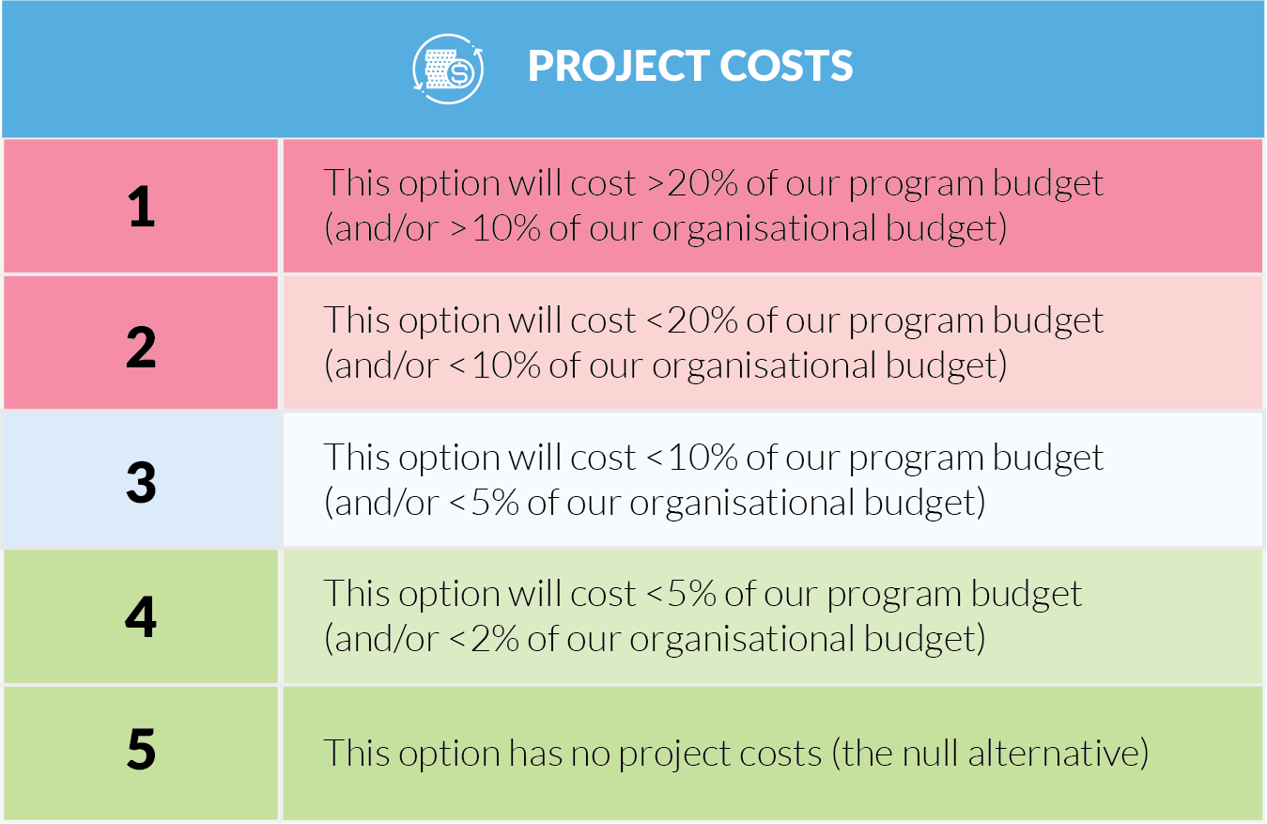
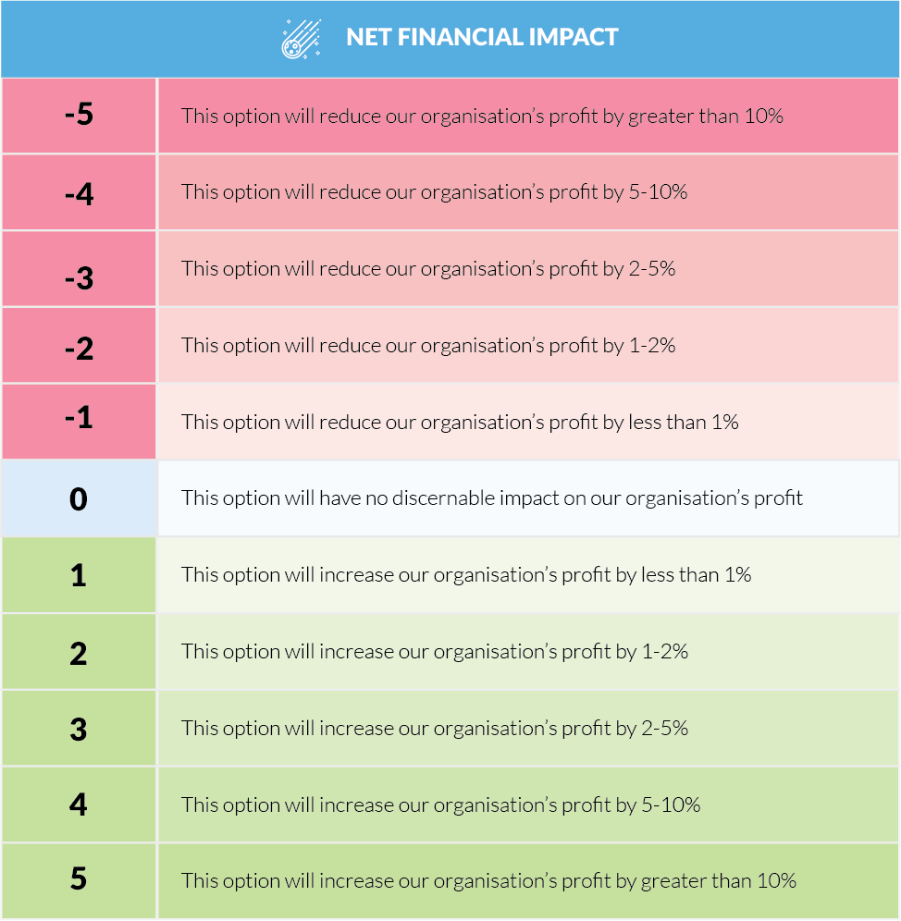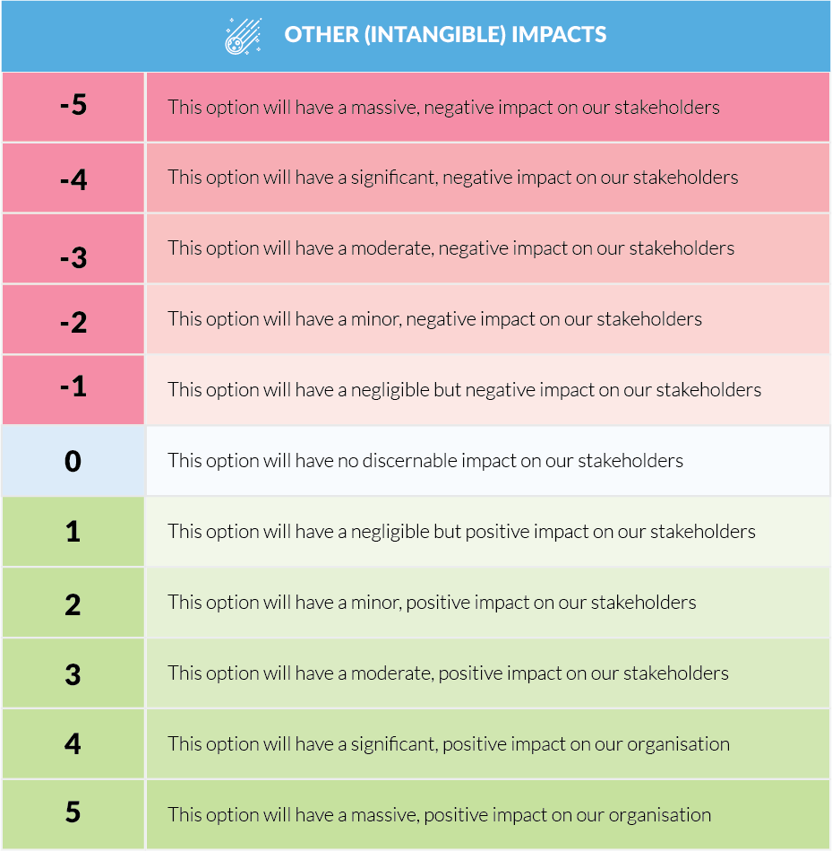
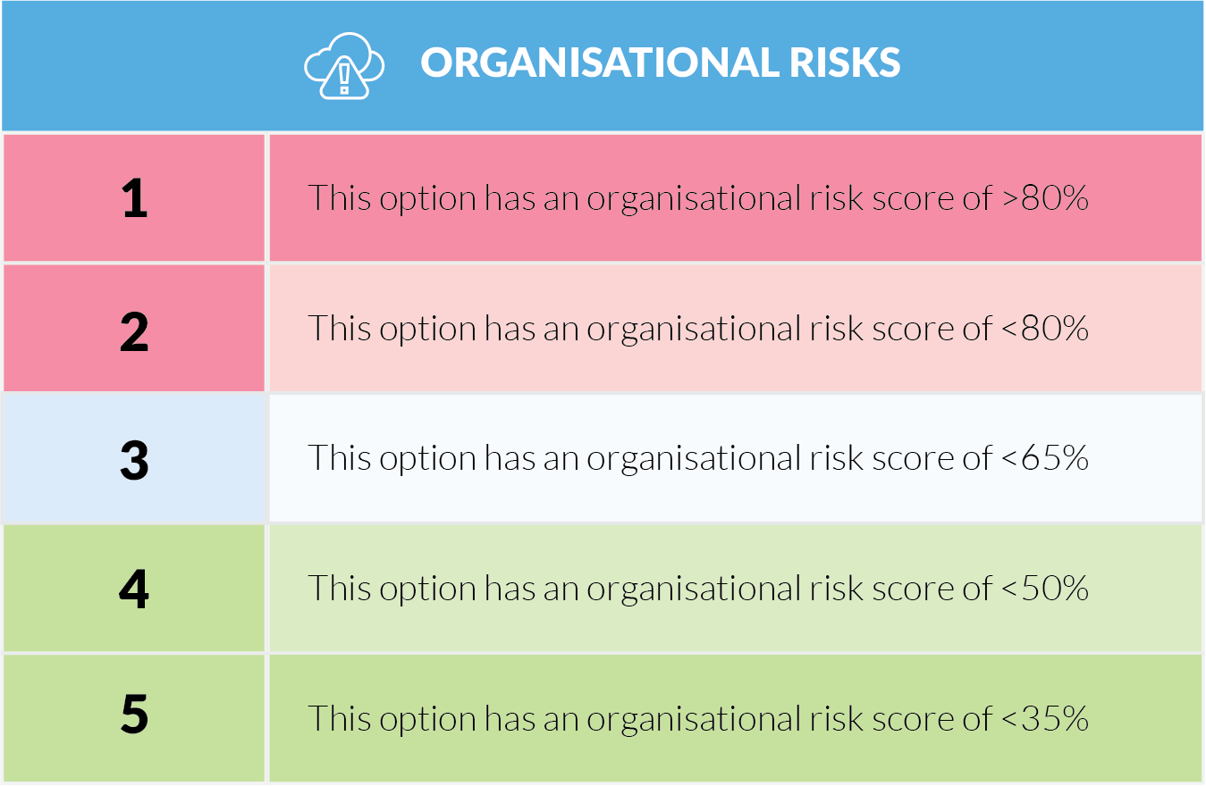

B FEASIBILITY STUDIES
An analysis of the feasibility of alternatives – including options not considered by the business case – may be attached here (for example, SWOT analyses).

C DETAILED COST BREAKDOWNS
This section details total costs for the project in terms of the major components of project costs, operating and ownership costs. Enough detail must be given to demonstrate that costs have been thoroughly analysed.
Costing should be exclusive of sales tax / GST.
The basis of the costing information should be given (for example, quotes, tenders, engineering reports). Refer to numbers and dates of quotes as appropriate.
The level of confidence in cost estimates must be clearly defined.

D FINANCIAL ANALYSES
Where opportunity costing, NPV or IRR calculations are made, detailed explanation of the motivating assumptions and models should be included here (usually in the form of a spreadsheet).

E TECHNICAL SPECIFICATIONS
Technical supplements that clarify some of the assumptions in the business case, such as detailed data tables, engineering reports and maps, may be included here.

F LEGAL / REGULATORY REQUIREMENTS

G SUPPLIER QUOTES, TENDERS AND CONTRACTS

H OTHER RELEVANT CORRESPONDENCE

I USEFUL CONTACTS

J CONFIGURATION HISTORY
This is version <n.n> of the <Project Name> Business Case.
J.1 Build status
Version | Date | Author | Notes | Sections

J.2 Amendments in this release
Section Title | Section Number | Amendment Summary

J.3 Distribution
Copy No | Version | Issue Date | Issued to

